Lab # 2
Wahaj Mehboob(380)
BSAI-3D
AI (LAB)
Question # 1
Create PEAS specifications for a delivery robot and an LLM-based student-support agent. Produce two separate PEAS specifications with all four components. For every component give at least two concrete entries where appropriate, then explain one constraint or performance trade-off. State the operational assumptions, including what tools the student-support agent can access. Put these specifications in your .docx report.
What I do in code:
- You created a dictionary, delivery_robot, that describes a robot using four parts: Performance, Environment, Actuators, and Sensors.
- You created a second dictionary, student_agent, with the same four parts, but for an AI that supports students.
- Each part holds a list of two items, such as "Wheels" and "Brakes" for the robot’s actuators.
- You printed a heading for each agent, then looped through its dictionary and printed every part with its items joined by commas.
- The output shows two clean summaries, for example Performance: On-time delivery, 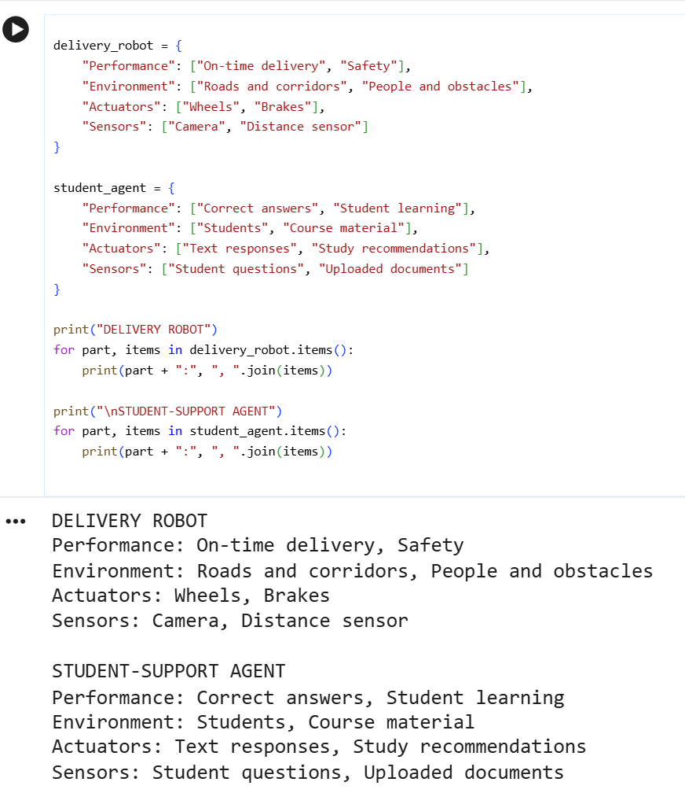

Code explanation:
- Both dictionaries follow the PEAS framework (Performance, Environment, Actuators, Sensors), which is a standard way to describe an AI agent.
- delivery_robot describes a physical agent: it is judged on on-time delivery and safety, moves with wheels and brakes, and senses with a camera and distance sensor.
- student_agent describes a software agent: it is judged on correct answers and student learning, responds with text and study recommendations, and senses through student questions and uploaded documents.
- The loop for part, items in ...items() takes each key (like "Sensors") and its list, and ", ".join(items) turns the list into one readable string.
- Together, the code shows that the same four-part structure can describe very different agents, one working in the physical world and one working in software.

Question # 2
Classify each environment as fully/partially observable and deterministic/stochastic with justification. Classify both systems from Task 1 on the two required dimensions. For each label give an example of an observable or hidden variable and an example of a predictable or uncertain action outcome. Distinguish the real environment from a simplified simulator; qualify your answer using stated assumptions
What I do in code:
- You created a nested dictionary, environments, that describes two agents: a Delivery Robot and a Student-Support Agent.
- For each agent, you classified its environment as partially observable and stochastic.
- You gave each agent a hidden variable (an obstacle behind a wall, or the student’s real understanding) and an uncertain outcome (a pedestrian crossing, or a student misreading an explanation).
- You wrote a loop inside a loop: the outer one prints each agent’s name, and the inner one prints each label with its value.
- You ended with a note saying these labels describe real environments, while a simplified simulator could be fully observable and deterministic.

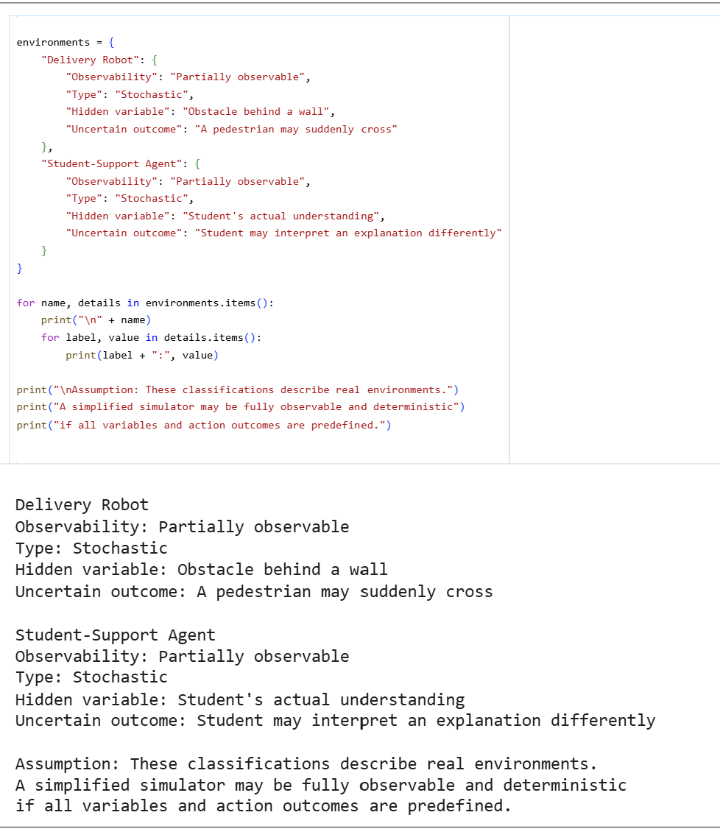
Code explaination:
- Partially observable means the agent cannot see everything it needs to know, so it must act with incomplete information.
- Stochastic means the same action can lead to different results, because of chance or outside factors.
- The robot is partially observable because its sensors cannot see behind walls, and stochastic because pedestrians behave unpredictably.
- The student agent is partially observable because it cannot see inside the student’s mind, and stochastic because students may react differently to the same explanation.
- The final note makes a good point: in a simulator, everything is predefined, so the environment can be fully observable and deterministic even though the real world is not.

Q # 3
Extend the code to remember the previous mode and avoid repeating identical control commands. Keep the existing temperature thresholds and occupancy priority. Add internal storage for the previous target mode, returning both the target and whether a command should be sent. Run repeated percepts, both exact boundaries, a mode transition and an empty-room case. Record previous mode, percept, target and command/no-command outcome.
What I do in code:
- You created a class, TemperatureControl, that remembers the last mode (OFF, HEAT or COOL) in self.previous_mode.
- The control method picks a target mode: OFF if the room is empty, HEAT below 18, COOL above 26, and OFF otherwise.
- It sets send_command to True only when the target differs from the previous mode, so repeated identical modes send nothing.
- It then saves the new mode and returns the old mode, the target, and the send flag.
- The loop runs 7 test readings and prints the previous mode, temperature, occupancy, target, and SEND or NO COMMAND.
Screenshot:
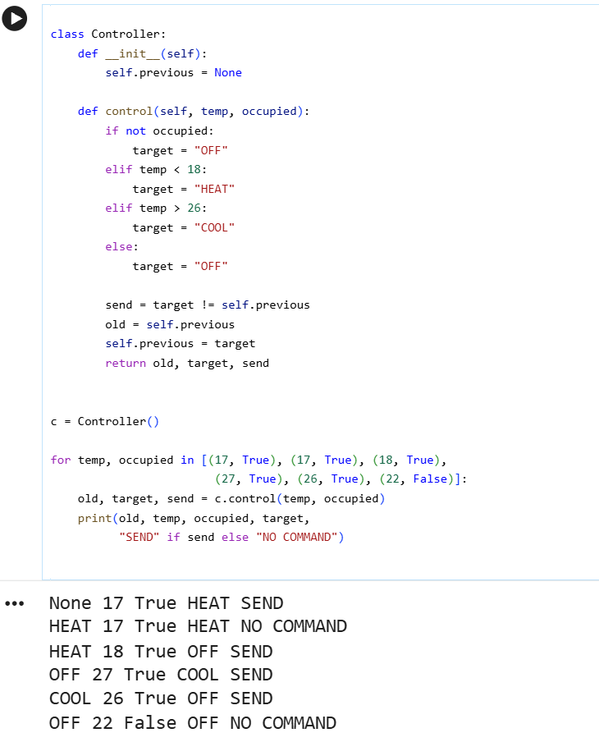

Code explaination:
- The first reading (17, occupied) gives HEAT, which differs from OFF, so it prints SEND.
- The second reading (17, occupied) gives HEAT again, so the mode has not changed and it prints NO COMMAND.
- The boundary tests show 18 is not below 18, so it goes to OFF (SEND), and 26 is not above 26, so it stays OFF after the 27 reading’s COOL: 27 gives COOL (SEND), then 26 gives OFF (SEND).
- The reading (22, occupied) gives OFF again, so it prints NO COMMAND, because the mode is already OFF.
- The last reading (22, empty) also gives OFF, so NO COMMAND again. This design avoids sending the same command repeatedly, which is the main point of the code.

